**Name:** Mahmoud Alaa Mostafa

**B.N /** 39

**Date/** (7-6-2021)

**S.N /** 857

**Topic:** Computer Architecture

**Application Brief:**

Because this topic is topics in one of the important Society at the present time because our society is now in continuous development in the field of computer engineering

**Source Code:** 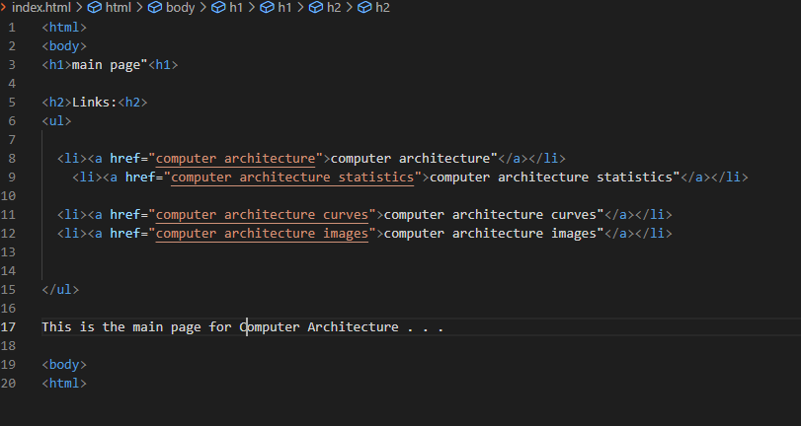

**Screenshots:** 